<https://www.cambly.com/en/student/courses/5e0e8b212ac750e7dc9886ac/5e41c3efcb33f779361e9a9a>

<https://www.cambly.com/en/student/courses/62cdf57ec3dbcad11563a640/62cdf8024c92873bf863a62f?lang=en>

###### Welcoming a Client

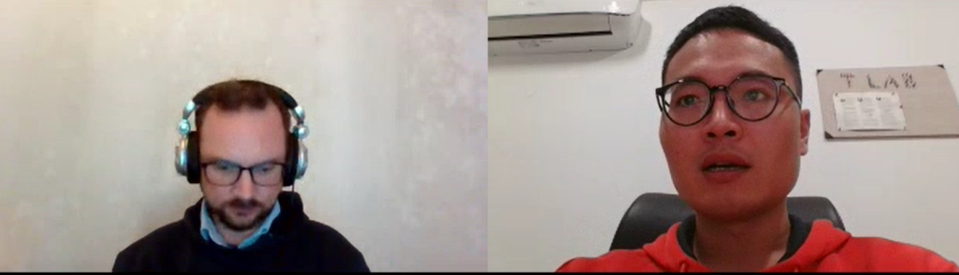

|  |  |  |
| --- | --- | --- |
| Clinic  Dental clinic 牙医  Health clinic | /ˈklɪnɪk/ | a medical establishment run by a group of medical specialists |
| Ailments  Sickness  Complaint 抱怨 | /ˈeɪlmənts/ | an often persistent bodily disorder or disease; a cause for complaining |
| Illnesses  Hospital | ˈɪlnəs/ | impairment of normal physiological function affecting part or all of an organism |
| Headset |  | Headphone with a microphone |
| What do you think about it |  |  |
| economics | /ˌiːkəˈnɒmɪks/ | Finance and economics |
| He is the first UK prime master of Indian heritage | /ˈherɪtɪdʒ/ | practices that are handed down from the past by tradition  他是首位研究印度遗产的英国首相  Cultural heritage  Natural heritage  Heritage preservation 遗产保 |
| Ethnic Chinese  Foreign citizen of chinese origin | /ˈeθnɪk/ |  |
| colony | /ˈkɒləni/ | a body of people who settle far from home but maintain ties with their homeland; inhabitants remain nationals of their home state but are not literally under the home state's system of government  Crown colony 英属殖民地  Bacterial colony |
| I solved something I have been working on for the last month | | |

.is more beneficial for me.

Subin Kim is a Social media analyst. She works in the marketing department at a company called Webfluence.

Hello. My name is Stuart, I'm a tutor with Cambly. The company is based in the US but I work remotely from France.

Nice to meet you (all)

cli yent

